**UML**

Submitted by

JILJO K GEORGE

MCA REGULAR  
 NO-28

**UML**

**ACTIVITY DIAGRAM(ADMIN)**

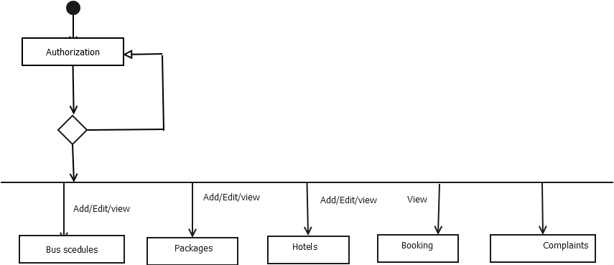

**ACTIVITY DIAGRAM(USER)**

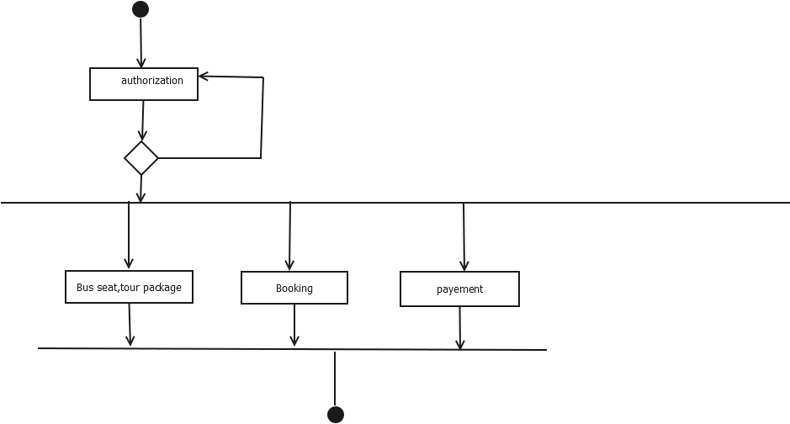

**COLABARATION DIAGRAM**

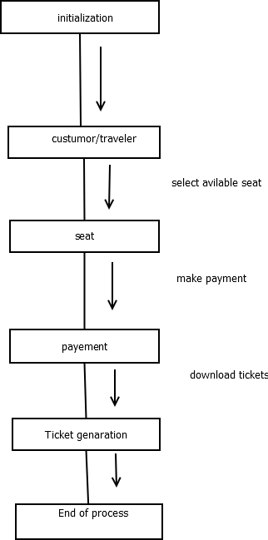

**OBJECT DIAGRAM**

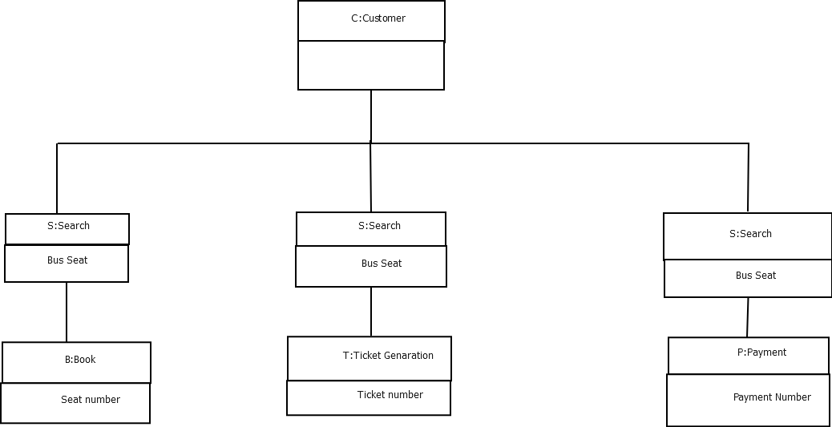

**CLASS DIAGRAM**

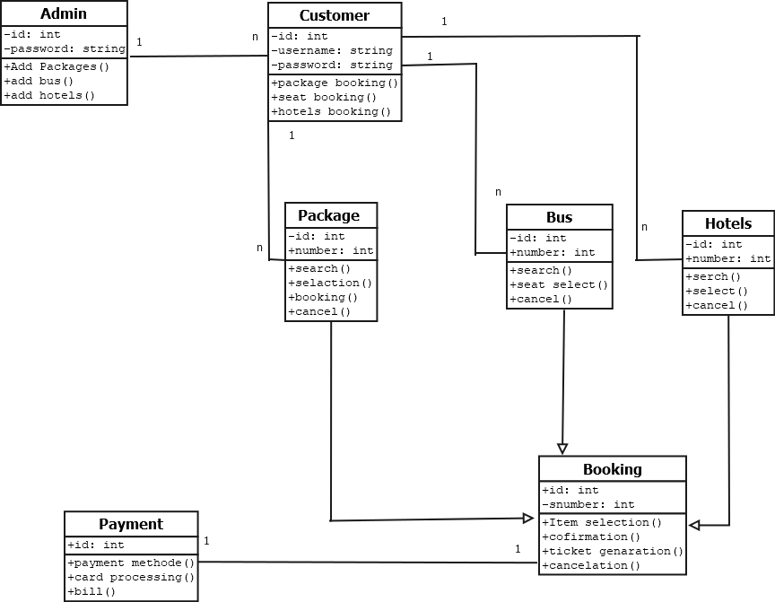

**SEQUANCE DIAGRAM**

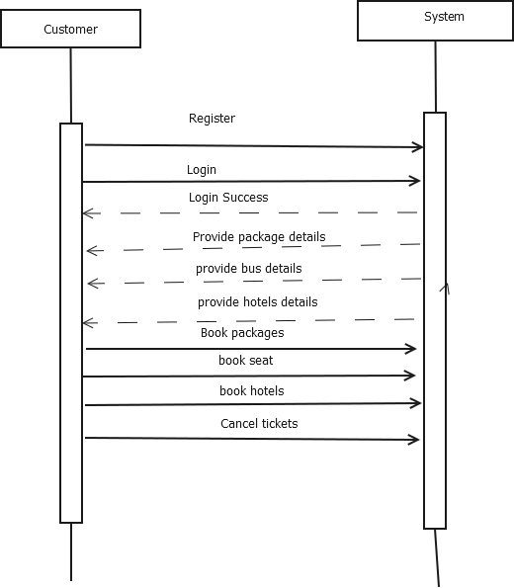

**USECASE DIAGRAME**

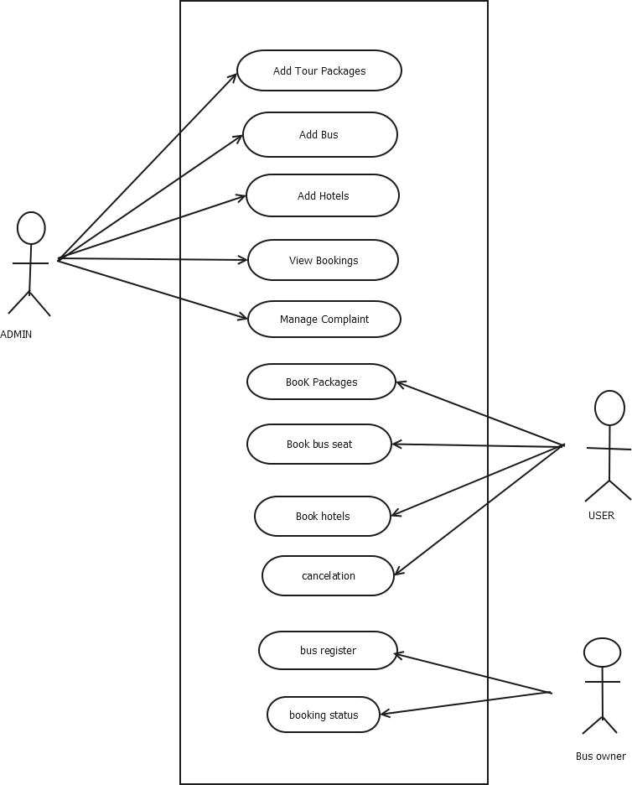

**STATECHART DIAGRAME**

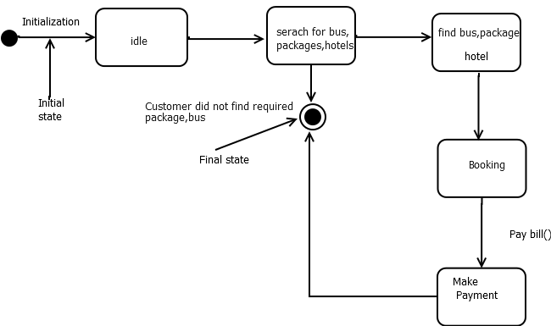

**DEPLOYEMENT DIAGRAM**

